Creativity and Learning: what is the connection?
Introduction
This paper argues that the positive impact that creativity has on the learning and attainment of children and young people is because creative learning develops the executive functions of the brain. To understand why this might be the case, it is important to consider why there is so much interest in creativity skills around the world, what we mean by creativity skills, and the characteristics of which learning environments have the most impact on developing them.
For a number of years the nurturing of creativity in children and young people has been a major concern of education internationally. This is certainly the case in Scotland where Scottish Government ministers have endorsed a national Creative Learning Plan, now being taken forward by Scotland’s key education organisations, together with committed partners from across the country. Central to this plan is a shared vision which recognises the need to prepare young people for life and work in an increasingly uncertain and rapidly changing economic and social environment. Creativity, it is argued, can help learners not only survive, but to thrive in the fast changing world in which they are growing up. Across the globe, similar arguments are being made by governments and educationalists and there are now a suite of programmes which have explored how young people can develop or enhance their creative abilities. This has now been picked up by the OECD who have launched a major international programme exploring how this can be achieved and whose participants include the governments of Thailand, Wales, Hungary, Russia, India, Brazil, Slovakia, and the USA .
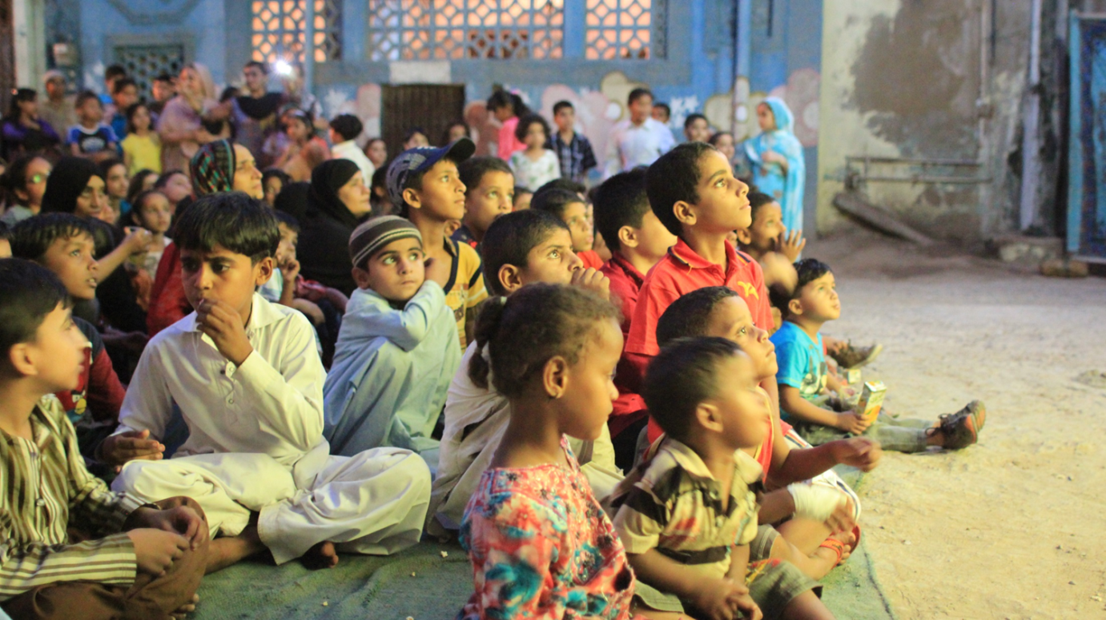
Central to this approach is the understanding that creativity encompasses a set of mental attributes which enable young people to succeed both in school and as adults in our complex and ever-changing world.
What we know about the impact that a focus on creativity has on the learning capacity of children and young people is derived from a number of programmes which have experimented with creative learning in the classroom. One of the best known of these initiatives is the Creative Partnerships programme, originally developed by the international foundation for creative learning, Creativity, Culture and Education (CCE) for the UK Government and deployed across schools in England from 2002 to 2011. Although funding was withdrawn in England in 2011 following the change of Government, the approach has been adapted and implemented by national, regional and local Governments in Lithuania, Norway, Holland, Germany, Hungary, the Czech Republic, Pakistan, Thailand and, most recently in Wales, where the Arts Council and the Government have launched a four year £20 million creative learning programme entitled Creative Learning through the Arts.
Research and evaluation has been central to the development of the Creative Partnerships approach. Since its inception in 2002, and through its development in other countries, extensive independent research has been commissioned to determine the programme’s impacts and outcomes. Subjects explored have included the extent to which the programme raises attainment, improves attendance, increases parental engagement and strengthens pupil engagement and well-being. In England, the programme was inspected by Ofsted twice and their reports published.

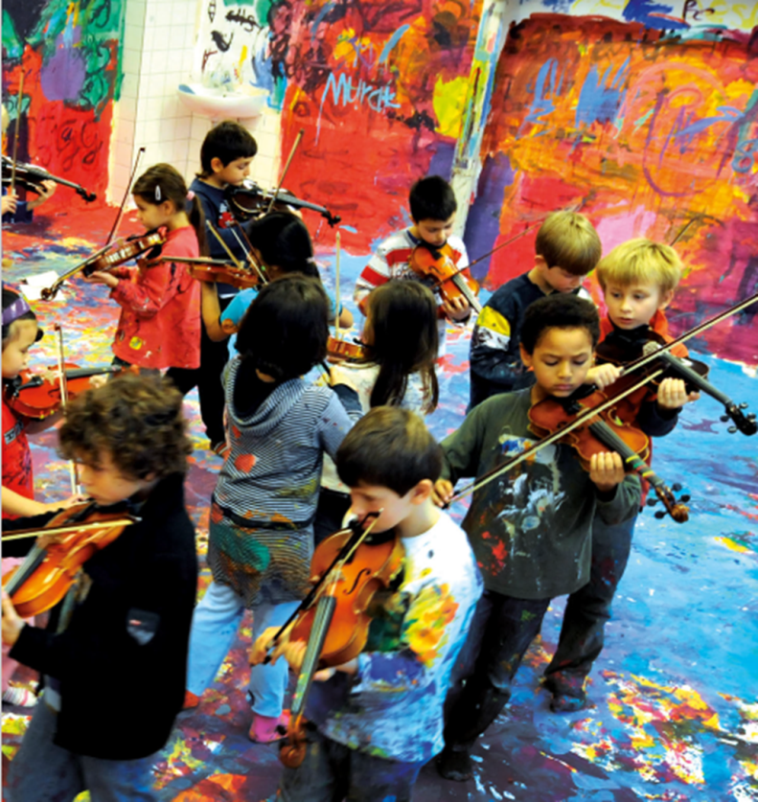

What are creativity skills?
To be able to assess the extent to which the creativity skills of children and young people are being enhanced, it is important to have clear definition of what they are. Creativity skills have been defined, debated, deconstructed and reassembled over several decades but there is now a growing international consensus as to what they are. While there are some differences in the words individual advocates of creativity might use, these differences are small. After reviewing the international literature, and having conducted some inspections of creative learning practice in Scottish schools, Education Scotland's Impact Report on Creative Learning identified four core creativity skills which apply across Curriculum for Excellence:
Constructively inquisitive, by:
- Being curious
- Registering patterns and anomalies
- Making use of previous knowledge
- Researching productively
- Formulating good questions

Open-minded, by:
- Using lateral thinking
- Using divergent thinking
- Hypothesising
- Exploring multiple viewpoints
- Being flexible, adaptable and functioning well with uncertainty

Able to harness imagination, by:
- Exploring, synthesising and refining multiple options
- Generating and refining ideas
- Inventing

Able to identify and solve problems, by:
- Understanding and defining problems
- Crafting, delivering and presenting solutions
- Demonstrating initiative, discipline, persistence and resilience
- Evaluating impact and success of solutions
- Identifying and implementing next steps in refinement or development process

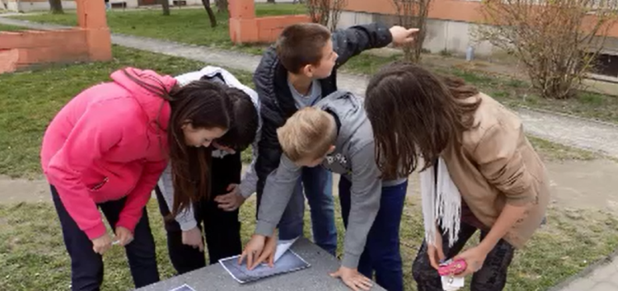

What learning environments are conducive to the development of creativity skills?
As positive reports began to emerge regarding the impact on pupil learning that a focus on creativity brings, international research shifted its focus to identifying and describing the learning environment in which creativity skills appear to thrive. Evaluations of the Creative Partnerships programme in England, such as Cambridge University’s The Impact of Creative Partnerships on the Well-Being of Children and Young People, showed that a student educated in a context in which they are an essential learning resource, and where mobility, emotion, team working and risk are central to the learning experience, is a student who is ‘high functioning’. In this form of education, the whole child is engaged in the learning experience, not only aspects of their mental processes. In other words, they are physically, socially, emotionally and intellectually engaged. It is this sense of being ‘high functioning’ which leads to feelings of well-being within the child, and this in turn builds the resilience and confidence which underpins successful learning. These practices are effective because they directly impact on the students’ sense of competency, autonomy and relatedness. They provide the sense of agency and motivation from which sustainable learning is generated. This is why Cambridge University found students at Creative Partnership schools to be more engaged, better behaved and achieving more. As the researchers explained:
“In this model of educational progression children move from a point where they acquire knowledge that is already known by others, to a point where they can order that knowledge within particular frameworks, to a further point where they can, without too much assistance, interrogate their own thought processes in creating their personal frameworks or restructuring existing knowledge.”
From a variety of different reports, the framework of such a learning environment began to emerge. Nottingham University, in particular, in their report The Signature Pedagogies Project: A Final Report were able to identify the range of pedagogies being deployed in Creative Partnerships programmes. Together with work from Winchester University, and the work of Cambridge University referenced above a clear picture began to emerge which is summarised in Figure 1 below.

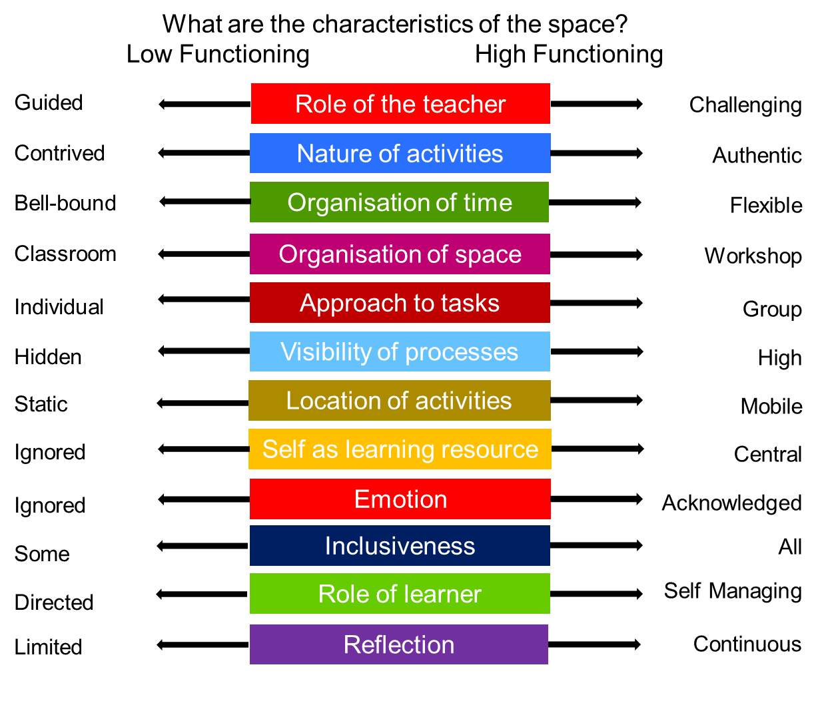
Figure 1: Characteristic features of the so-called ‘high functioning classroom’
This is not to argue that the ‘low functioning’ classroom environment is wrong. There are occasions when a frontal, transmissive style of teaching is appropriate. There are also some pupils who prefer a more passive style of learning. However, where this becomes the dominant or single pedagogy being deployed, it fails to engage the majority of pupils in their learning sufficiently to achieve the degree of focus, concentration and motivation that deep learning requires.
How does this connect with Executive Functions of the brain?
There are a number of reasons why creativity is so strongly linked to executive functions of the brain.
Firstly, there are strong similarities between the language being used by psychologists to describe executive functions and the language being used in Scotland to define creativity. This is clear when you compare descriptions of executive functions with the definition of creativity skills quoted earlier. In Figure 2 below the Scottish creativity skills are compared with standard definitions of executive functions of the brain. Although the individual skills are grouped under different headings, the similarity is immediately obvious. As a result, it is hard to avoid the conclusion that they are actually the same set of attributes.

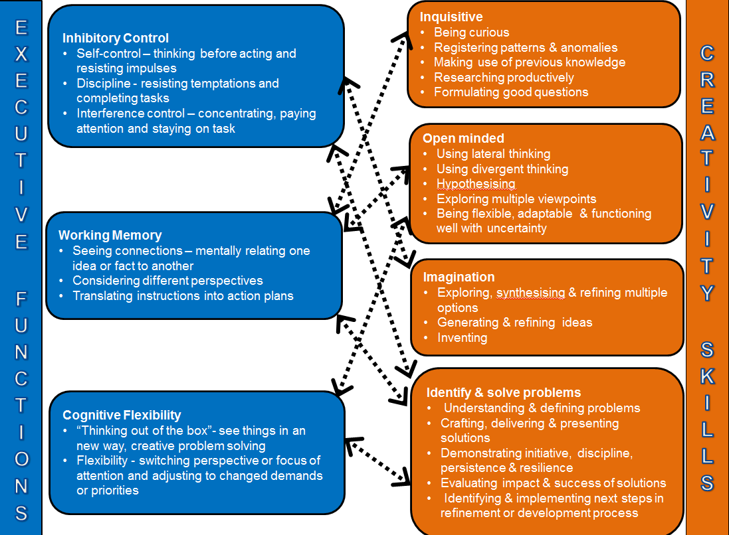

Figure 2: Comparison between the Executive Functions and Creativity Skills
Secondly, executive functions’ researchers are clear about the classroom conditions under which executive functions are developed. Adele Diamond, in her summary of Executive Functions of the brain explains:

Because EFs are critical for academic achievement, a society that wants its students to
excel needs to take seriously that the different parts of the human being are fundamentally
interrelated. If emotional, social, or physical needs are ignored, those unmet needs will
work against good EFs and hence against academic excellence.

In other words, unless children and young people are physically, socially, emotionally and intellectually engaged through their learning, their executive functions will not develop, and this will undermine their capacity to learn. As explained above, research into embedding creativity in learning reached the same conclusion. It too has identified the need for the emotional, social and physical needs of the child or young person to be addressed and established that when this is achieved, learning outcomes improve. This is enshrined in the concept of the ‘high functioning classroom’. If exactly the same approach to managing the learning environment is shown to be successful in nurturing creativity as well as developing executive functions of the brain it is likely to be because there is no real difference between creativity and that of executive functions.

Thirdly, there is a very strong correlation between the development of executive functions and socio-economic status (SES). Children living in poverty are far more likely to arrive in school with less developed executive functions. This reduces their capacity to learn effectively. As a result they soon start to fall behind. However, CCE has shown that approaches to learning which focus on creativity are particularly successful in raising performance in schools serving the most deprived communities. For instance, when Ofsted inspected Creative Partnerships in England in 2010 they found:

Schools in challenging circumstances ̶ those with a higher than average proportion of pupils eligible for free schools meals, low attainment on entry and high rates of pupil mobility ̶ showed the greatest improvements in pupils’ ability to draw discerningly on a range of data and work collaboratively to solve problems; their reading and writing; their speaking and listening; and their personal development.

Given that approaches to learning known to improve executive functions had been deployed, and given improvements in executive function would be most obvious in children from lower SES backgrounds, it cannot be a coincidence that the greatest improvement reported by Ofsted in learning is detected amongst children from the poorest background. Again this strongly suggests that executive functions and creativity skills are one and the same. It is important to note in this context that research into executive functions have found the same effect: Adele Diamond notes:

The children most behind on EFs (including disadvantaged children) benefit the most from any EF intervention or program (Flook et al. 2010, Karbach & Kray 2009, Lakes & Hoyt 2004). Hence, early EF training might level the playing field by reducing social disparities in EFs, thus heading off social disparities in academic achievement and health (O’Shaughnessy et al. 2003).

What is the connection with learning through the arts?

In the Creative Partnerships programme, specially trained artists and creative practitioners are deployed in the classroom to work with teachers and pupils to develop projects which address specific issues. In the training artists are introduced to definitions of creativity (such as the Creativity Skills as defined in Scotland) and theories of learning (including learning environments which nurture creativity such as the high functioning classroom). They are trained in the use of a variety of instruments which aid planning and implementation (such as the Creative School Development Framework and programme planning and evaluation frameworks). Finally, they are supported to develop effective approaches to project management. The training also helps them identify their own development needs, which can be addressed through the implementation of the programme. The training itself models the characteristics of a ‘high functioning classroom’ and introduces the participants to a variety of successful case studies and exercises which they themselves can use or adapt.

The projects developed with the schools address all areas of the curriculum, as well as issues of behaviour, engagement, attendance and motivation. The projects are all arts based, but they are usually addressing issues arising in other subjects, such as maths, literacy, history or the sciences.

The use of the arts as the basis of the activities that are designed and deployed in the classroom is derived from their ability to incorporate with ease the elements of the ‘high functioning’ classroom.
So for instance:

- The arts immediately introduce emotion into an activity.
- The physicality of the activities is derived from dance and theatre techniques.
- Children and young people are given challenges in which they translate their understanding into artistic forms, so that they can make manifest their learning through painting, drawing or composing.
- Story-telling and performance provide the opportunity for children and young people to share their own experiences and perceptions.
- The artistic output which is usually shared beyond the classroom with the rest of the school, the pupils’ families and the wider community, ensuring that their learning is highly visible.
- Time is used more flexibly to ensure that the time available is flexed to meet the needs of the activity, rather than the other way around.
- The activities connect with the world outside with the child’s inside, hence making the activities feel authentic.
- There is a lot of group work and collaboration in the arts practices deployed.
- Reflection is ongoing and considers both what learning is taking place and why the learning process was effective.

The arts therefore, provide a framework which ensures that the pupils are physically, socially, emotionally and intellectual engaged, hence providing the learning environment known to develop creativity and enhance executive functions of the brain.

Conclusions

Creativity skills therefore appear to be synonymous with executive functions of the brain. This explains why a focus on nurturing creativity skills has been shown to improve learning, and why the impact appears to be greatest among children and young people from more deprived backgrounds. Executive functions of the brain are also known to be capable of improvement. Weak executive functions are not an immutable ‘condition’. The correct approach in the classroom is known to improve them. In fact, as Adele Diamond points out, weak executive functions can often be confused with disorders:

These can cause you to appear to have a disorder of EFs, such as ADHD, when you do not…… If we want schoolchildren, workers, or business executives to have better attention and concentration, be better able to reason and problem solve, we cannot ignore stresses in their lives. Each schoolchild and each employee will do better if that individual’s passionate interests can be engaged, energizing the person. They will perform better and show better EFs if they feel they are in a supportive community they can count on. They will perform better and show better EFs if their bodies are strong and healthy. A school or corporation that ignores students’ or employees’ emotional, social, or physical needs is likely to find that those unmet needs will work against achieving performance goals.

In conclusion, executive functions are critical for many of the skills that people agree will be important for success in the twenty first century. They make it possible for us to play with ideas, quickly and flexibly adapt to changed circumstances, take time to consider what to do next, resist temptations, stay focused, and meet novel, unanticipated challenges. Everything, in other words, that creativity skills help you to do, and why they are so important to nurture in children and young people. They also provide the foundations for effective learning as defined in the Scottish Government’s How Good is Our School 4, as they produce learners who:

are confident and ambitious with high levels of self-esteem. They are motivated to explore and challenge assumptions. Children and young people take ownership of their own learning and thinking. They are imaginative, open-minded, confident risk-takers, and appreciate issues from different perspectives. They can ask questions, make connections across disciplines, envisage what might be possible and not possible, explore ideas, identify problems and seek and justify solutions.

Creative Partnerships, together with other similar approaches such as those developed through the Creative Learning Networks in Scotland, have shown that these skills can be effectively developed through a programme of teacher/artist partnerships, where learning through the arts can be spread across the curriculum and throughout the school.

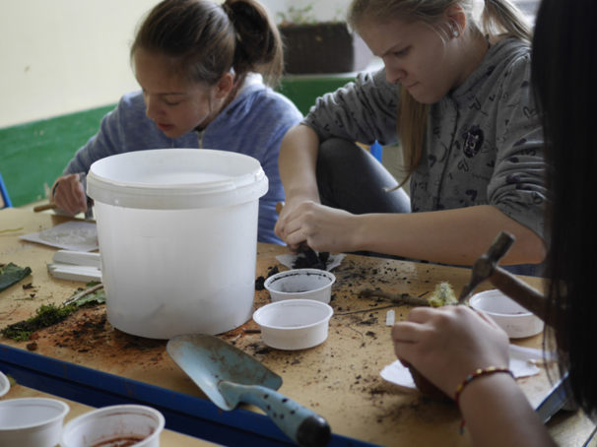

For instance in Holland there is Ons Onderwijs 2032 http://onsonderwijs2032.nl and in Norway The School of the Future https://www.regjeringen.no/en/dokumenter/nou-2015-8/id2417001/
Assessing progression in creative and critical thinking skills in education, Organisation for Economic Cooperation and Development. https://www.oecd.org/fr/sites/educeri/assessingprogressionincreativeandcriticalthinkingskillsineducation.htm
Ofsted (2006) Creative Partnerships: Initiative and Impact. (HMI 2517) Manchester: Ofsted and Ofsted (2010). Learning: creative approaches that raise standards (HMI: 080266)
For instance Sharp. et al. (2006). National Evaluation of Creative Partnerships. http://www.nfer.ac.uk/nfer/publications/CPS01/CPS01.pdf Ofsted 2006. Creative Partnerships: initiative and impact. The impact of sustained partnerships between schools and creative practitioners as a result of Creative Partnerships initiatives. London. http://www.creativitycultureeducation.org/wp-content/uploads/ofsted-creative-partnerships-report-15-15.pdf Eames, A., Benton, T., Sharp, C. and Kendall, L. (2006). The Impact of Creative Partnerships on the Attainment of Young People. https://www.nfer.ac.uk/publications/CPS03/CPS03_home.cfm
McLellan, R., Galton, M., Steward, S. and Page, C. (2012). The Impact of Creative Partnerships on the Wellbeing of Children and Young People. Newcastle: CCE, http://www.creativitycultureeducation.org/the-impact-of-creative-partnerships-on-the-wellbeing-of-children-and-young-people
Thomson, P., Hall, C., Jones, K. and Sefton-Green, J. (2012). The Signature Pedagogies Project: Final Report. Newcastle: CCE, http://www.creativitycultureeducation.org/the-signature-pedagogies-project
Spencer, E., Lucas B. and Claxton G. (2012). Progression in creativity: Developing new forms of assesment. Newcastle:CCE. p.34-35. http://www.creativitycultureeducation.org/wp-content/uploads/Progression-in-Creativity-Final-Report-April-2012.pdf
Executive Functions - Annual Review of Psychology Vol. 64: 135-168 (Volume publication date January 2013) First published online as a Review in Advance on September 27, 2012 DOI: 10.1146/annurev-psych-113011-143750
Ofsted. (2010). Learning: creative approaches that raise standards (HMI: 080266)
Executive Functions - Annual Review of Psychology Vol. 64: 135-168 (Volume publication date January 2013) First published online as a Review in Advance on September 27, 2012 DOI: 10.1146/annurev-psych-113011-143750
The Creative Schools Development Framework is an instrument devised by CCE to facilitate a constructive analysis of a school’s starting point in order to identify priorities for improvement.
Executive Functions - Annual Review of Psychology Vol. 64: 135-168 (Volume publication date January 2013) First published online as a Review in Advance on September 27, 2012 DOI: 10.1146/annurev-psych-113011-143750

